2022 Exhibitor’s Guest Special Pass
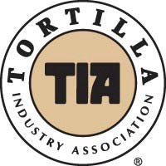
As a special courtesy in appreciation of your patronage, the TIA Exhibitor below is pleased
to offer you this $99 PASS
(a $475 value each) valid for TIA Annual Convention (May 17-19 Planet Hollywood)
It includes:
- Opening Reception May 17th
- Two days of Educational Sessions May 18-19
- Two days of Exhibits with Buffet Lunches May 18-19
For AGENDA and other Details please visit: www.tortilla-info.com
GUEST OF EXHIBITOR: ______________________________BOOTH#____________
Attendee Name:
Additional attendee Name:
Attendee’s Company _______________________________________________
Spouse Name: Spouses FREE in 2022
Address:
City: State: Zip:
Phone: __Guest Email: ______ (REQUIRED)
Phone: __Guest Email: ______ (REQUIRED)
Available Extra Options:
[ ] Golf, May 17: golfer names____________________________________Handicap ____$129
[ ] Entertainment & Awards Banquet, May 18th ______________ $175 Each

Optional Payment Information, if any:
Optional Golf x $99
Banquet x $175 WAIT LIST
Total Due For Extras
Card Number: Exp Date:
Card Holder Name: Signature:

TO REGISTER:
E-Mail This Form to: info@tortilla-info.com
Or Register ON-SITE (banquet will be wait-listed)

