25-26 October 2022
Aarhus, Denmark!
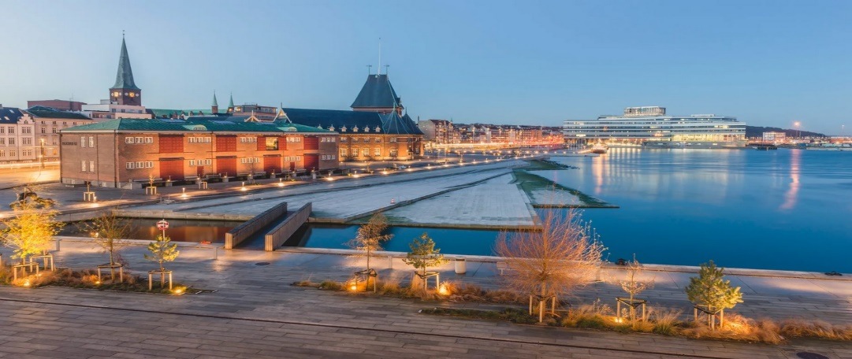
Location: Hotel Comwell Aarhus by Wyndham, €135 a Night Includes Breakfast
Sponsorship & Registration Form
NAME__________________________________________ E-Mail ____________________________________________
TITLE_________________________________ COMPANY _________________________________________________
ADDRESS_________________________________________________________Phone__________________________
CITY____________________________________ STATE___________ ZIP___________ COUNTRY _______________
Registration Per Person ____ 750 € Before 10 October – or 950 € after 10 October
Registration Fee Includes: Classes + Lunches + Cocktail Reception + Tours + Dinner
Commercial Opportunities:
[ ] 750€ Tabletop Exhibit at Cocktail reception 25 Oct [ ] 550€ full-page color Ad in program book
[ ] 3,000€ Lunch sponsor 25 Oct [ ] 2,500€ Dinner sponsor 25 Oct [ ] 750€ Coffee Breaks
PAYMENT Total = ________ BY: [ ] Credit Card (write below) [ ] Check (attached)
Cardholder _________________________________Card # _____________________________________Exp_______
NOTE: For Wire Transfer Payment: Contact Jim Kabbani for TIA’s Bank Details
Send To: BY Postal Mail: TIA, 1400 North 14th Street, Arlington VA 22209, USA
BY E-Mail: Scan & Send To jkabbani@tortilla-info.com
Questions? Please Also Contact Jim Kabbani
NOTE: Currency conversion rate plus our bank fees set at 7.44 DKK per Euro and 1.23 USD per Euro .
See www.tortilla-info.com for details - Agenda subject to change.

