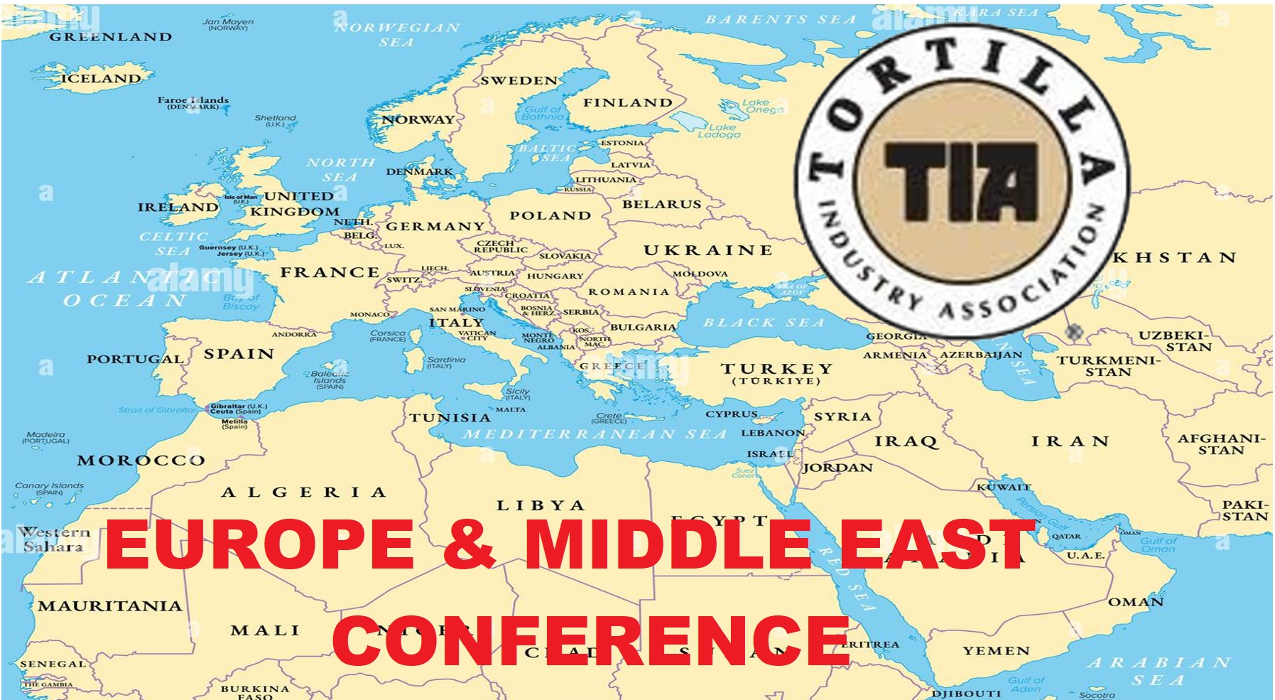
5 - 6 November, 2026
Barcelona, Spain
Hyatt Regency Tower Hotel
Registration & Sponsorship Form
NAME 1 ____________________________________________ E-Mail _________________________________________________
NAME 2 ____________________________________________ E-Mail _________________________________________________
NAME 3 ____________________________________________ E-Mail _________________________________________________
COMPANY ________________________________________________COMPANY TYPE: [ ] Tortilla Producer [ ] Supplier to industry
ADDRESS_____________________________________________________________________Moble Phone_________________________
CITY____________________________________ STATE/PROV_________________ POSTAL___________ COUNTRY ________________
Registration Fees (Per Person)
____ x 550 € Producers Rate (applies ONLY to companies making tortilla or flat bread) (550 € charged as $650 USD)
____ x 350 € Additional Person from Same PRODUCER Company only (350 € charged as $420 USD)
____ x 950 € Suppliers (companies that sell ingredients, equipment or services) (950 € charged as $1,200 USD)
____ x 650 € Sponsoring Supplier staff per additional Person (650 € charged as $775 USD)
____ x 350 € Guest of Supplier (guest from tortilla or flatbread producing company ONLY) (350 € charged as $420 USD)
____ x 75 € Dinner Ticket (optional, limited 60 seats only) (75 € charged as $90)
All Registration Fees Includes: Classes + Lunch + Coffee Breaks + Cocktail Reception + Optional Bus)
Commercial Opportunities:
[ ] 1500€ Tabletop Exhibit during the Cocktail Reception + lobby brochure (limited number) +1 free conference registration
(1500 € charged as $1,750 USD)
[ ] 3,500€ Lunch Sponsor +2 free staff [ ] 3,500€ Reception +2 free staff [ ] 3,500€ Dinner +2 free staff
(3500 € charged as $4,200 USD) (3500 € charged as $4,200 USD) (3500 € charged as $4,200 USD)
[ ] 550€ full-page program book ad (multiple available) [ ] 950€ Bus Sponsor (950 € charged as $1,200 USD)
[ ] 750€ Break Sponsor (3 available) (750 € charged as $895 USD)
For Customer Passes, Contact Jim Kabbani: jkabbani@tortilla-info.com or SMS to +1.703.819.9550
For Tabletops & Sponsorship Questions, Contact Terri Owens: terri@tortilla-info.com or SMS to +1.301.367.8200
PAYMENT Total = ________ BY: [ ] Credit Card (write below) [ ] Wire Transfer – details from jkabbani@tortilla-info..com
By Credit Card
Cardholder Name_________________________________ Card # ______________________________________________Exp______________
NOTE: For Credit Card Payments, TIA Will Convert Your Cost Upon Processing to US Dollars As Per Above:
NOTE For Wire Transfer Payment Details: Contact Jim Kabbani for TIA’s Bank Details jkabbani@tortilla-info.com
and ask your bank convert Euros to current US Dollars. All fees associated will be your responsibility.
Send: BY Postal Mail: TIA, 1400 North 14th Street, Arlington VA 22209, USA
BY E-Mail: Scan & Send This Form To jkabbani@tortilla-info.com
** CANCELLATION POLICY: No refunds, only credit towards future TIA events up to the last day of next calendar year **

