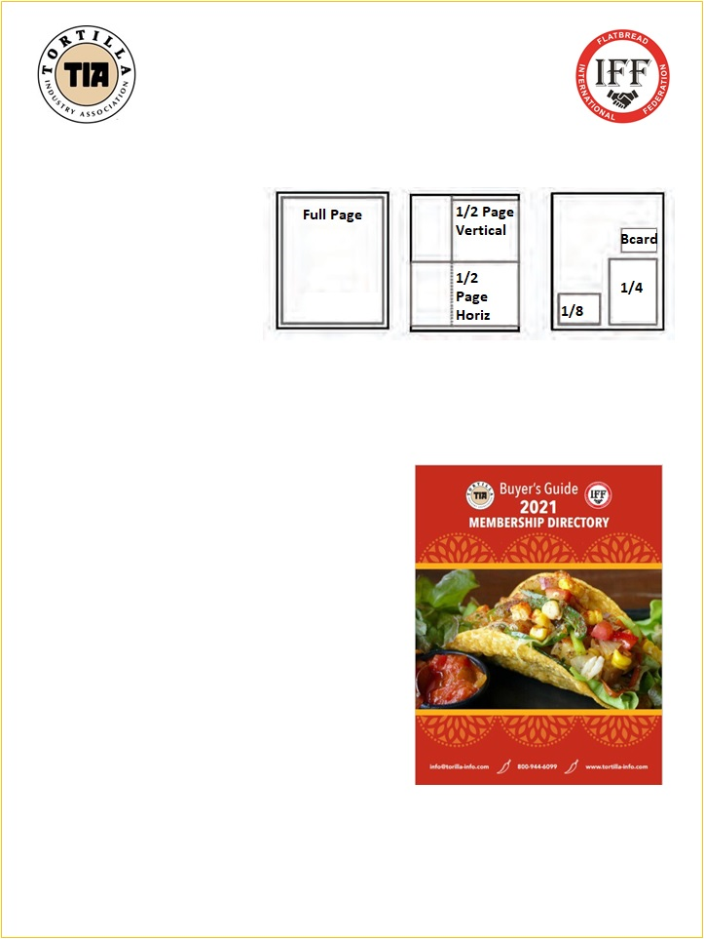
2021 TORTILLA INDUSTRY ASSOCIATION BUYER’S GUIDE & MEMBERSHIP DIRECTORY

MEDIA KIT

AD DEADLINE IS: NOV 9th
The Tortilla Industry Association (TIA) was created in 1989 to serve the tortilla industry, now the fastest growing segment of the baking industry. In the U.S., annual sales of tortillas exceed all other ethnic and specialty bread sales, including bagels, croissants, muffins and pita bread.

CIRCULATION: The TIA Buyers Guide and Membership Directory is mailed in print and electronically to over 6,000 recipients as well as posted free of charge on the TIA website.

AD SPECS

Full Page | 8.5 x 11 | (Full Bleed 8.75 x 11.25)
Half Page Horiz. | 8.5 x 5.5 | (Full Bleed 8.75 x 5.75)
Half Page Vert. | 4 x 10.5 | No Bleed
1/4 page | 3.75 x 5 | No Bleed
1/8 page | 3.5 x 2.5 | No Bleed
Business Card | 3.5 x 2 | No Bleed

Print safe zone on half and full page ads: 0.25in

Please provide a high resolution ad (300 DPI or higher) in TIFF, PDF, AI or PSD format.

All fonts outlined or flattened.

All ads must be converted to CMYK. No RGB or spot colors allowed.

No Microsoft Word documents or web images will be accepted.

SEND ADS TO:
Terri Owens terri@Tortilla-Info.com
1-800-944-6099 ext 2 / www.Tortilla-Info.com

AD DEADLINE IS NOV 9th

