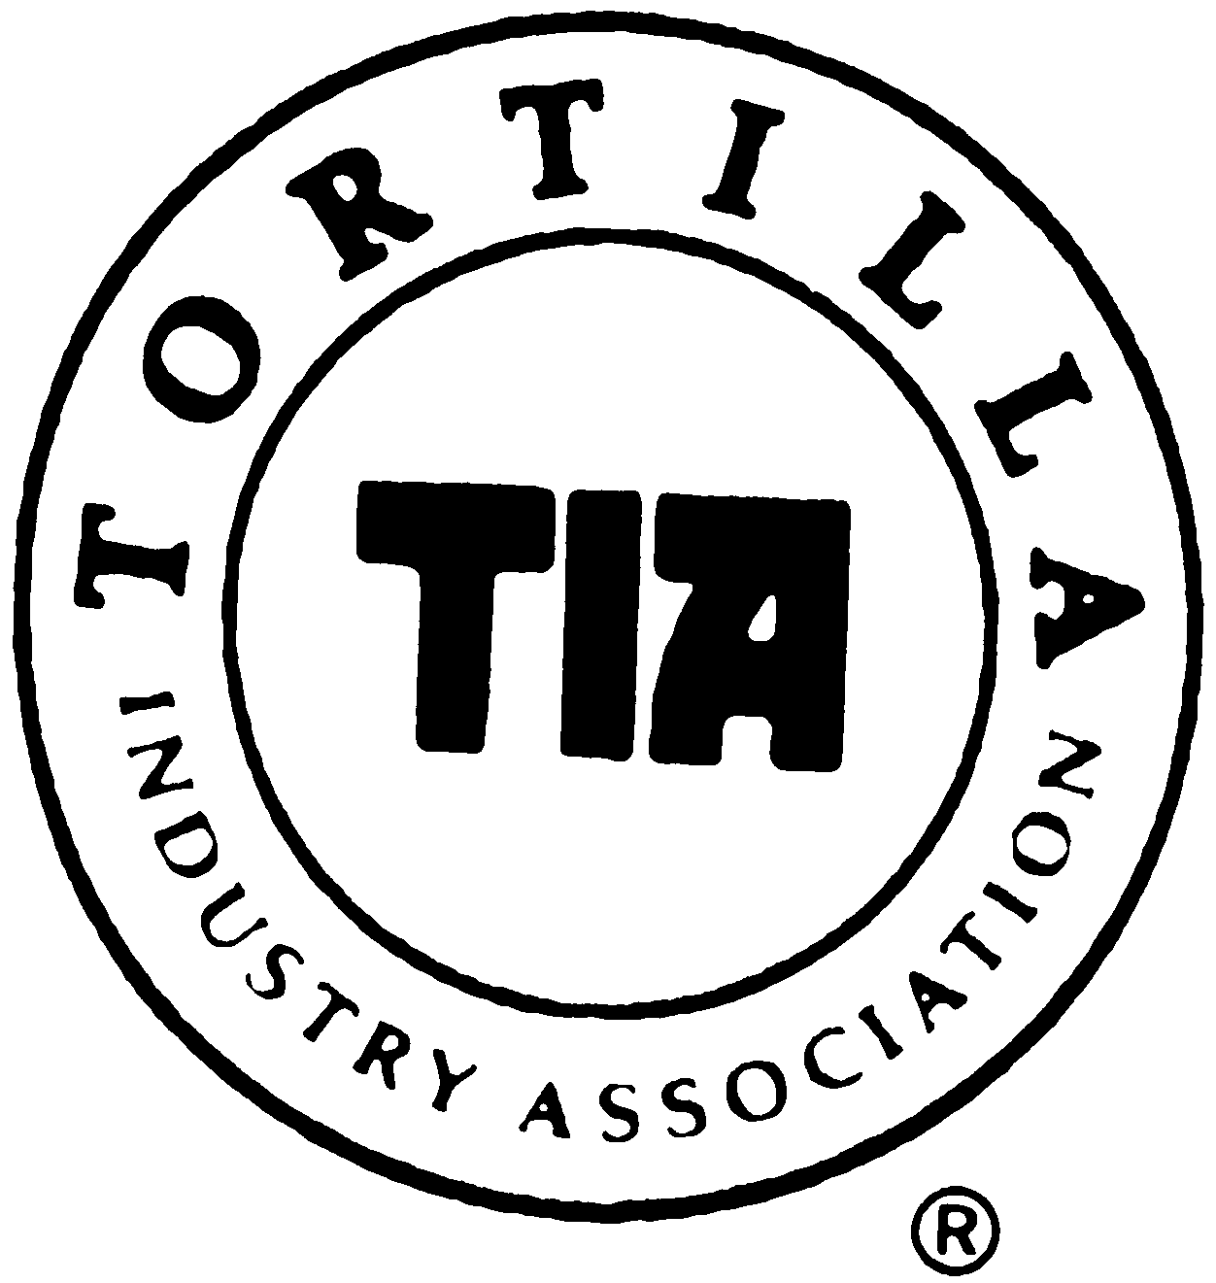
2021 Hall Of Fame
Nomination Form

Name of person you would like to nominate:_________________________________________
Their Company & City / State:______________________________________________________
Are they: [ ] Living [ ] Deceased (if so, nearest living relative__________________)
Your Name: ___________________________________________________________________
Your Company & City / State:______________________________________________________
Your Phone: _________________________ Your E-Mail:________________________________

PLEASE describe your Nominee’s contributions to the Tortilla industry or why you feel they should be in the TIA Hall of Fame:__________________________________________________
______________________________________________________________________________
______________________________________________________________________________
______________________________________________________________________________
______________________________________________________________________________
______________________________________________________________________________
______________________________________________________________________________
______________________________________________________________________________
______________________________________________________________________________

NOTE:
1. Application is not considered complete without nominee’s PHOTO and BIO
2. At least 1 person from winner’s company MUST be present at Banquet
DEADLINE: June 7th 2021

