
Heat and Control Inc.
T: +1 510 259 0500
info@heatandcontrol.com ⎟ heatandcontrol.com

Press Release
For Immediate release Heat and Control Inc., Hayward CA 10 August 2026.

Trailblazer Andy Caridis embodied integrity and championed innovation.

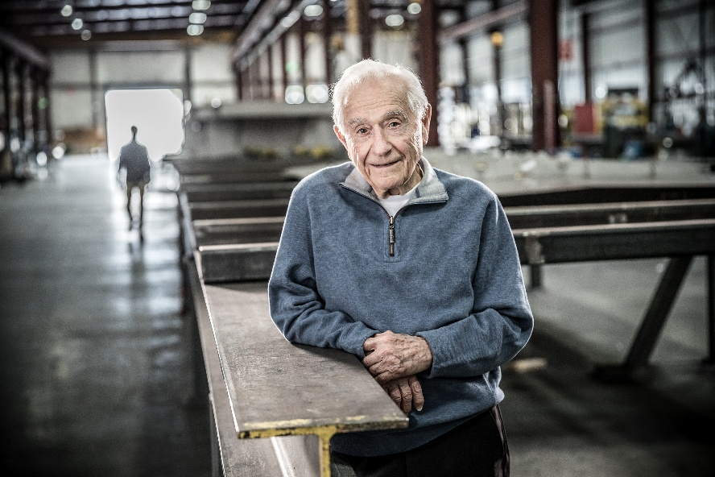
With heavy hearts the Heat and Control family grieves the passing of inspirational founder Andy Caridis. Andy passed away peacefully on June 29th, 2026. He lived 105 incredible years, and his depth of character, focus, determination, and innovative spirit leaves an inspirational legacy for his family and Heat and Control.
Andy’s focus on innovation was instrumental in how Heat and Control began 76 years ago, and key to how the company operates today. Andy was one of a kind, a deep thinker who searched for ways to make things better. As seen in his large body of work across the globe and patented technologies, Andy’s methodology and design influenced food production and how society feeds the world. His impact, either direct or developed under his leadership, are mainstays in today’s food production systems and the foundation for future advancements.
Andy was enthusiastic about the fantastic products that can be made with corn and was proud to grow alongside the now successful companies that have built a thriving industry. Deeply thankful for the relationships developed within the Tortilla Industry Association and member community, Andy was honored to receive TIA Hall of Fame recognition in 2021.
Andy encouraged others to be leaders of change and to invest time and energy in research and development. Andy knew success was about more than a single machine, understood that things did not happen overnight (or in a bubble), and that long-term partnerships and support through the life of a product were key. Andy was dedicated to the success of others. He cared about Heat and Control employees and their families, valued collaboration and the remarkable things that working together can accomplish and measured his success alongside the success of customers.
Andy meant what he said, did what he said he would do, and did the right thing. He inspired everyone he met and worked with over his dynamic life, and he will be missed by all.
The Caridis family sincerely thank the Heat and Control family, partners and customers for immeasurable support and condolences.
The family request that as an alternative to sending floral tributes and in memory of Andy’s focus on learning, growing, and improving every day, please support a local grassroots organization that provides education or training programs to help honor Andy’s focus on innovation and life-long learning.

(end)

