Dr. Lloyd William Rooney
July 17, 1939- June 23, 2019
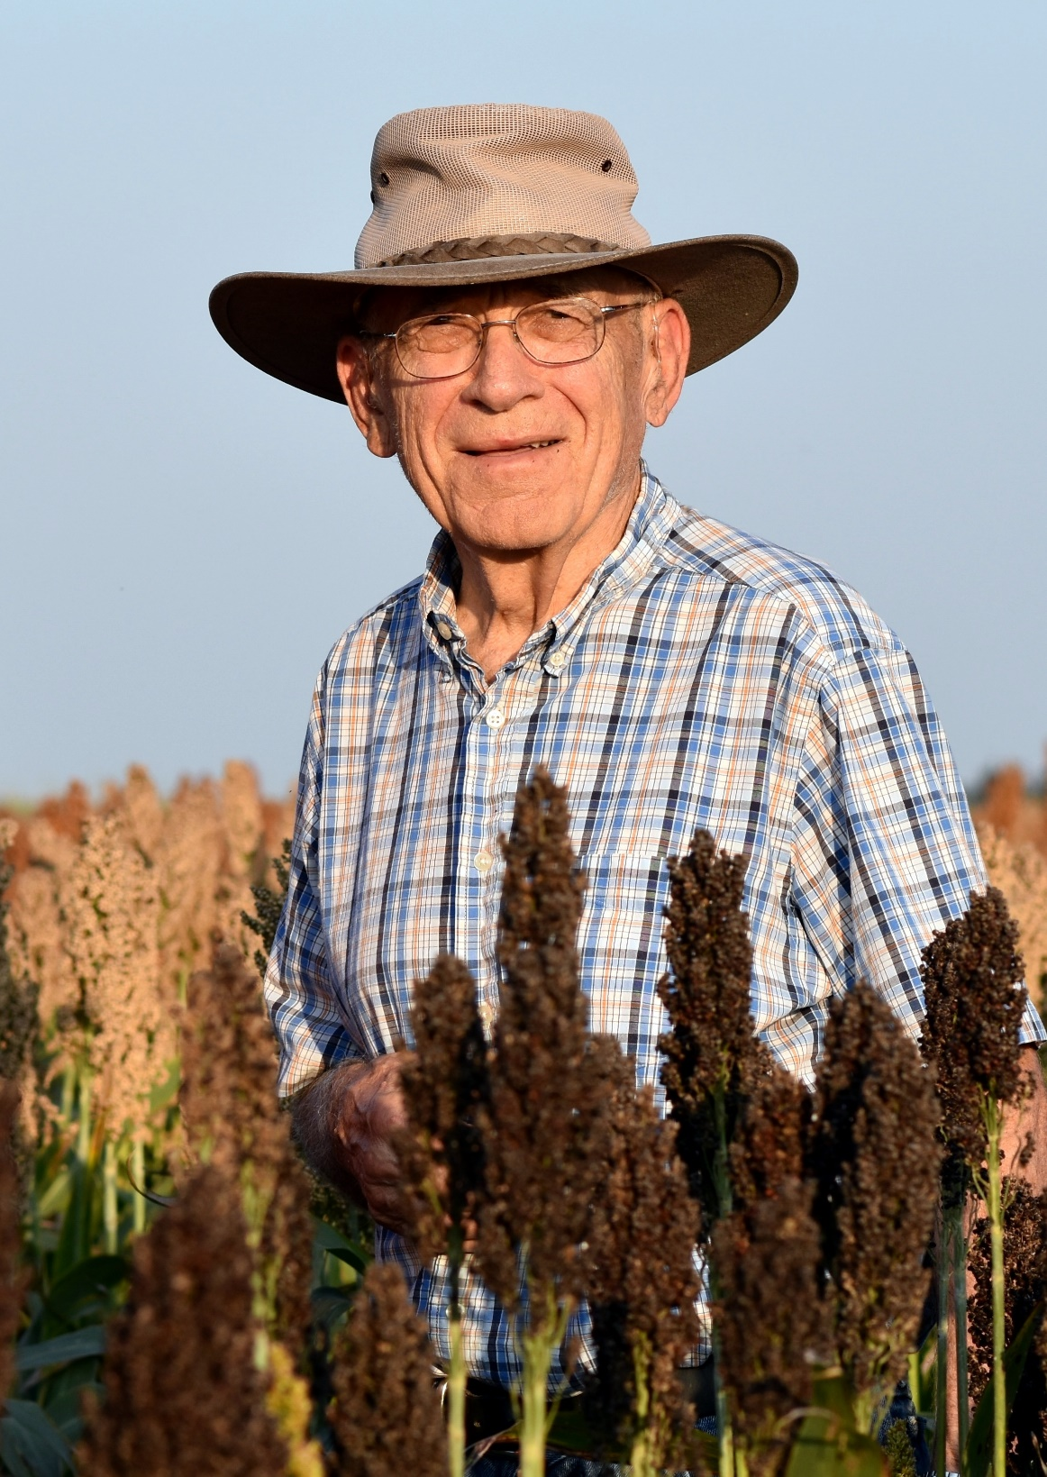
All of us at TIA are deeply saddened to have just been informed by Mrs. Maxine Rooney that her husband our much-admired friend Dr. Lloyd Rooney, Professor Emeritus in the department of Soil and Crop Sciences, passed away on June 23, 2019 in his home, surrounded by family.
We have been told that a Funeral Mass was held at 10am, Friday, June 28, 2019, at St. Thomas Catholic Church and interment followed at 1:30pm, Friday, June 28, 2019 at Mt. Calvary Cemetery. Services were in the care of Callaway-Jones Funeral and Cremation Centers, Bryan-College Station.
He was born to Tamzen and Lloyd Rooney on July 17, 1939 in Rawns County, Kansas. He was raised on the family wheat and cattle farm in Rawlins County, learning the value of hard work through farm chores with his five siblings. He attended elementary school in a one-room school house and later graduated from McDonald High School in 1957. He attended Kansas State University, earning a B.S. in 1961 and a Ph.D. in 1965, both in Grain Science.
After completion of his studies in 1965, he accepted a faculty position in grain quality at Texas A&M University, where he remained until retirement in 2013. Over his 48-year tenure, his research and teaching activities in the Cereal Quality Lab focused on the improvement of grain structure and chemistry of corn, sorghum and wheat for food utilization. He worked with crop improvement programs domestically and internationally (Africa, India and Latin America) to develop crop cultivars with improved grain quality. In addition to research, Dr. Rooney advised more than 130 students to graduate degrees in Food Science; many of these former students have further impacted grain quality research globally.
Dr. Rooney was recognized for his research impact on numerous occasions including: The Texas A&M University Regents Award; Texas A&M College of Agriculture Awards for Teaching; Research and Collaborative Team Research; the Mexican National Academy of Science Distinguished Researcher Award; the American Association of Cereal Chemistry Research Award and International Fellow of the American Association of Cereal Chemistry.
Lloyd is survived by his wife of 55 years, Maxine Rooney, their three children (and spouses); Bill (and Megan) Rooney of College Station, TX, Tammy (and Steve) Duke of Lucas, TX, and Marcille (and Salvador) Aldrett of Katy, TX. Lloyd was a proud grandfather to William, David and Travis Rooney; Kaitlyn, Cassandra and Caroline Duke; and Andrew, Marielle, Gianna, and Annelise Aldrett. His great-grandchildren, Liam Rooney and two more due within the year, also survive him. When not working on research and teaching, Dr. Rooney loved to spend time on their small ranch near Kurten where he and Maxine have lived for the past 43 years. Lloyd and Maxine are parishioners of St. Mary’s Catholic Church.
Lloyd always told his children to leave the world a better place than they found it for themselves, their descendants, and others; we all feel that he did exactly that through his example as a devout family man, and through his research and training of grain scientists working to help feed millions around the world.

