IN MEMORIAM – Samuel Magaña
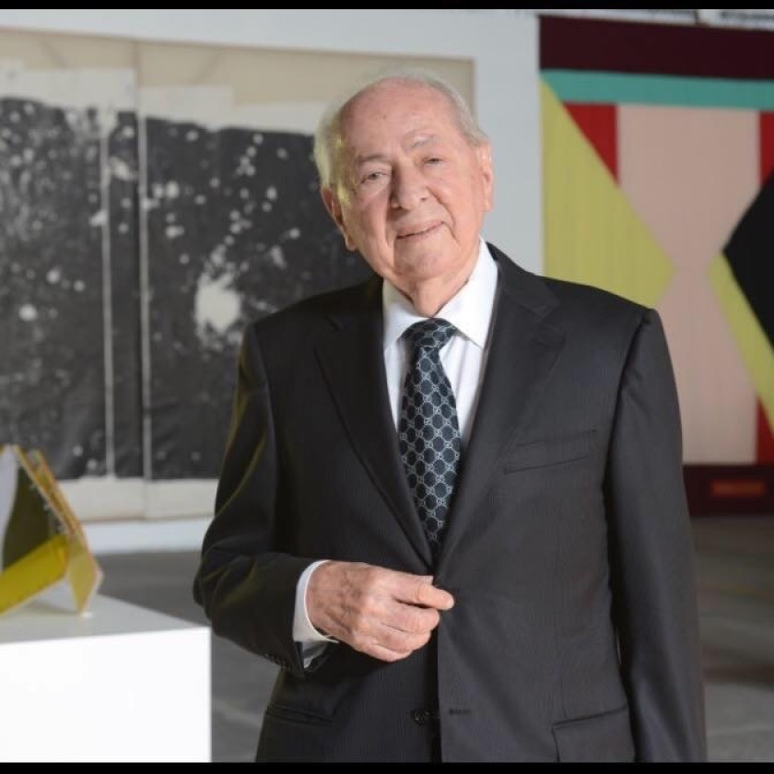
When Samuel Magaña decided to leave his pueblo in the Mexican state of Durango at 14 to work in the United States, his father put some coins in his hands and some advice into his mind:
“If you go, you have to work hard. If you don’t work hard, no one will give you anything.”
The teenager found that out almost immediately. Magaña had to hang from a railcar to evade Border Patrol agents and cross into the United States. He picked fruit and cotton in the Central Valley and took classes to learn not only English, but also how to write in Spanish, since his education back home had ended in the third grade.
Arriving in Los Angeles in the 1950s, Magaña became general manager of a Mexican food factory owned by Romana Acosta Bañuelos, who went on to become the first Latina to serve as U.S. treasurer. He used that experience to open a small market in Gardena with his wife that they named after their first daughter, Diana.
Over the next 50 years, the Magañas grew Diana’s Mexican Food Products into a $35-million Norwalk-based conglomerate that now includes five restaurants, two tortilla plants, a tamale factory and an industrial bakery. Their corn and flour tortillas are staples of small markets across Southern California; their delivery trucks — emblazoned either with a photo of a smiling 3-year-old Diana that serves as the company’s logo or a 1990s-era shot of an adult Diana with her brother and sister as they stand behind a cornucopia of their family’s products — are part of the Southern California landscape.
“He came to this country to make money, period,” said his daughter Diana. “And so that way, he could help his family but also others.”
Magaña died Monday of natural causes. He was 88.
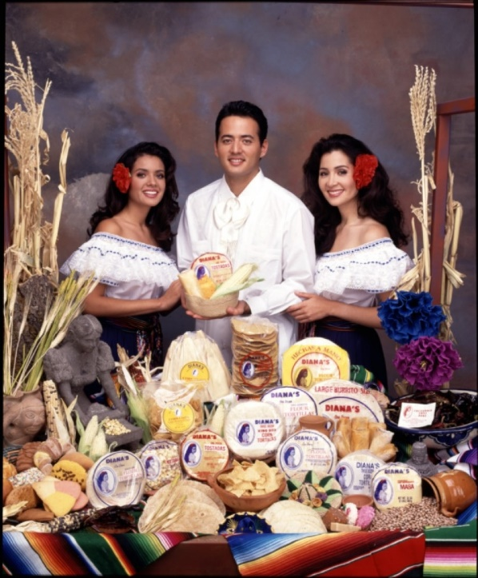
“May his legacy endure among us as an inspiration to continue working on behalf of our fellow men, as he did in his life,” Marcela Celorio, Mexico’s consul general in Los Angeles, said in a statement. Becoming a tortilla mogul happened to Magaña by accident. He had no restaurant experience when he began to work in 1950 for Bañuelos, who ran a Mexican deli near downtown Los Angeles at the time. Four years later, he helped her open Ramona’s Mexican Food in South Los Angeles, and stayed on as the plant’s general manager for the next 15 years. At Ramona’s, Magaña met and married Hortensia Rodriguez, who convinced him that the two should open their own business. So in 1969, the young parents bought a market in Gardena and converted a back room into their living quarters. On weekends, Samuel drove to Tijuana to bring back as many products and ingredients as possible to sell to the growing Mexican population in the South Bay.
“Every morning before I would go to school, I’d see customers come in and talking to my parents,” said his daughter, Diana Magaña-Haagen. “They had that immigrant spirit you hear and read about. They didn’t have an education, but they were streetwise.”
Tensha, Sam Jr. and Diana Magaña appear in a 1994 publicity photo for Diana’s Mexican Food Products.(Courtesy of Diana’s Mexican Food Products)
While the market and restaurant flourished, what really took off were Hortensia’s homemade corn and flour tortillas. Former cooks told Samuel to sell them some to use at their new restaurants. Customers asked for dozens to go. Markets wanted packets to stock.
Remembering the large-scale skills Samuel learned at Ramona’s, the Magañas opened their first tortilla factory in Maywood in 1973. In addition to their own line, Samuel co-packaged products for private labels and created specialty items for clients. Among Diana’s customers: Taco Bell founder Glenn Bell, who commissioned Magaña to improve his taco shells.
“There is no other country like this country for opportunities,” Magaña told the Los Angeles Times in 1983. “Anybody who is determined to become successful can do it.”
And in a foreshadowing of Mexican food’s global popularity, Samuel and his family traveled to Japan as early as the 1990s to hawk their products; today, Diana’s says it’s the country’s most popular tortilla brand.
“My mom was the ambitious one with ideas,” said their daughter Tensha Magaña Berry. “My dad was the hard worker who took pride in being able to produce whatever the demands of the consumer.”

But even as the company grew, Magaña insisted his family stay with tradition. While competitors cut their masa with cheaper ingredients to reduce costs, the company continues to nixtamalize its own corn, resulting in a better, earthier flavor for tortillas and tamales. When Diana suggested that the family replace the photos of her and her siblings for a more contemporary look, her father refused.
“Dad said, ‘No, this is a family-run business,’” she said. “‘This is what people know us as. This is important.’”
Magaña worked at Diana’s until about two months ago, and spent his off-time on philanthropy. He and his wife provided funds to build a basketball court and a children’s park in his hometown of Amaculí, a learning center in Huntington Park and even helped Mexican immigrants transport their deceased family members back to Mexico for burial.
“When I envision him, what comes to mind is how employees would stop him in the parking lot and he’d talk to them all as long as they wanted,” said Sam Jr., now president of Diana’s. “He’d give them interest-free loans, or just relationship advice — whatever they needed. He never forgot his roots. He remembered that he was one of them, too.”
Magaña was preceded in death by his wife, who passed away in 2008. He is survived by his children Diana, 55, Sam Jr., 49, and Tensha, 45, and seven grandchildren.
“His biggest legacy wasn’t the empire but that we can walk around and meet people, and they just love us because of our father,” said Diana. “They just transfer that love to us.”
+ + +

